BE AN ACTIVE CITIZEN
THE AMAZON RAINFOREST EDITION
Today you will create a 30 second movie that informs the public of the need to protect the Amazon Rainforest. The steps below will help you direct an Academy Award winner!

- Through Cobb Digital Library-search “Tropical Rainforest” on Brainpop.
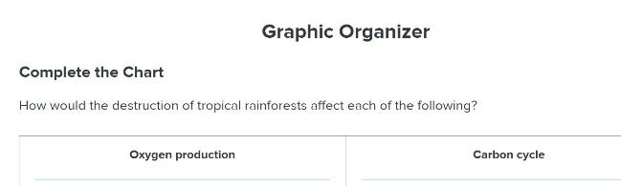
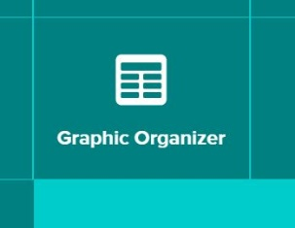
- BEFORE watching, either print or copy the graphic organizer found when you click “graphic organizer”

- As you watch the video, complete the organizer with at least 3 bullets for each topic. You can stop the video if needed or watch multiple times.
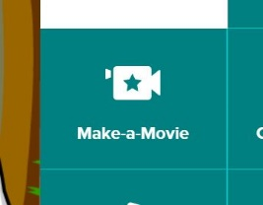
- Once you have seen the video, you are ready to “Make a Movie” -an easy (and fun) feature on BrainPop!

- To get started-choose one of the letters displayed to answer in your movie. Your choice!
- Look back on the notes you took, which ones will help you in your movie? Highlight those notes for easy reference.
- Now it’s up to you to work your creative magic! Parameters: A 20-30 second movie will be enough to answer the question. Stick to the question and the “script”. INCLUDE a call for action (ask the viewer to help in a specific way-check out suggestions on the “How to Help” handout.)
- When you are done, show your movie to your family-Share (ON Office 365) a picture of your “Movie Night” with your teacher and 2 reviews from family members (A sentence of what they have learned).
This Photo by Unknown Author is licensed under CC BY-NC-ND
And the winner is….
YOU!

