Vocabulary Practice and Study Tool Creation Options

Flashcards  - Use an index card and put the term on one side and the ENTIRE definition on the other  - You may use strips of notebook paper if you do not have index cards | Word search  - Use the ENTIRE definition as the clue for the word  - Circle the answers in your word search  - Graph paper is suggested, but not required
Crossword puzzle  - Use the ENTIRE definition as the clue for the word. Below is an example of what a crossword puzzle looks like  - You must include the answers in a different colored writing utensil  - Graph paper is suggested, but not required  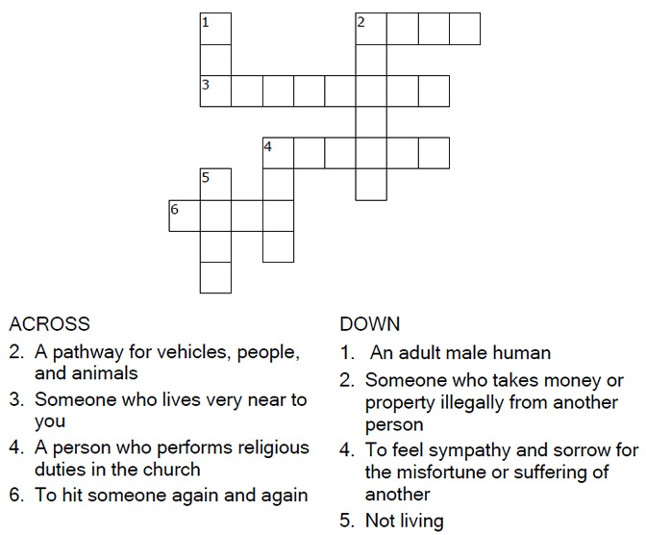 | Frayer model  - Draw a box (like pictured below) and fill in the boxes with the described information  