Name: _________________________________________________________
European Government Teacher Notes
- Various Forms of Government

Vocabulary Preview
• autocratic – a government where political authority rests with a single leader
• bicameral – having a legislature divided into an upper and a lower house
• chancellor – title given to the head of government in Germany
• democratic – a government where political authority rests with a nation’s citizens
• political party – an organization which represents a specific political agenda and socioeconomic positions within a given nation
• president – title often given to the head of government (and state) in a presidential democracy
• prime minister – title often given to the head of government in a parliamentary democracy

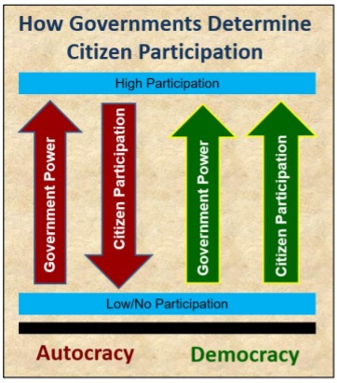
World governments, and the roles citizens are permitted to play therein, can be classified as either autocratic systems or democratic systems. In an autocracy, all governing authority rests with a single leader. The citizens in an autocracy are not permitted any say in the decisions of their government. In contrast, democracies vest political power with their citizens. This power is exercised through voting.
Germany, Russia, and the United Kingdom are all classified as democracies, although to different degrees. All three nations hold elections at the local and national levels. Germans, Russians, and Brits all elect legislators to represent their interests and pass equitable laws, and there are many political parties to choose from in each nation.
Executive leadership in each country varies. In the case of the U.K., the head of government is a prime minister; however, the nation’s monarch serves as a symbolic head of state. In Germany, the head of government is a chancellor, which is synonymous with a prime minister. Both Germany’s chancellor and the U.K.’s prime minister are elected by each nation’s Parliament, and both are limited to two consecutive five-year terms in office. In contrast, Russia’s head of government is a president. The Russian president is directly elected by the Russian citizens and may serve for two consecutive six-year terms. (The term length of the Russian president was extended from four to six years in 2008.)
It should be noted that Russia was, until the 1991 collapse of the Soviet Union, an autocratic state. Although civil liberties and government transparency have improved in Russia since the Soviet era, its democratic institutions are comparably not as vibrant as Germany’s or the U.K.’s.
The voting age in Germany, Russia, and the United Kingdom is 18; Germans may, however, vote in state level elections at age 16.
Like the United States, all three aforementioned European nations have bicameral (i.e., two-house) legislatures. In Germany, these houses are the Bundesrat (boon-dess-RAHT) and Bundestag (boon-dessTAHK). In Russia, it is the Federation Council and State Duma (DOO-mah). In the U.K., it is the House of Lords and the House of Commons.
- Parliamentary & Presidential Democracy
Vocabulary Preview
- parliament – common name given to the legislature in a parliamentary democracy
Democracies may be classified as either parliamentary or presidential.
In a parliamentary democracy, the citizens elect members of the nation’s legislature (typically referred to as its parliament) to represent their interests and pass laws on their behalf. These legislators are then vested with the authority to elect the nation’s chief executive. This head of government is selected from among the members of the nation’s leading political party (i.e, those who won the most seats in parliament.) Both the U.K. and Germany exercise a parliamentary system of government.
In a presidential democracy, the citizens elect both the nation’s legislators and its chief executive (typically given the title president.) Whereas the head of government in a parliamentary democracy is held accountable by his/her own political party, the head of government (and state) in a presidential democracy is directly accountable to the voters who put him/her in power. Russia has a presidential democracy.
Economics Teacher Notes
Vocabulary Preview
• bartering – a system of exchange whereby one good/service is given in return for another; bartering does not require monetary exchange
• command economy – an economic model wherein government planners make all business and financial decisions
• economic system – an economic model used by governments to determine what should be produced/provided in terms of goods and services, how, and for whom
• entrepreneurship – the capacity of private citizens to create new businesses independent of government direction or intervention
• free enterprise – the creation, maintenance, and expansion of businesses outside the control or influence of the government.
• market (or capitalist) economy – an economic model which the laws of supply and demand (not government oversight) determine what is produced/consumed and at what cost
• production quota – the required amount of a specific good that must be produced in a given timeframe
• subsistence – producing only what is necessary for personal use/survival
• traditional economy – an economic model governed by custom, habit, and history
• wage – term for one’s financial earnings

Every country on Earth must be able to answer three basic economic questions: 1) What should the nation produce/provide? 2) How should the nation produce/provide this product/service? 3) For whom should the nation produce/provide this product/service? As such, countries must adopt (and adapt) various economic systems to answer these three questions.
There are three basic economic models (or systems):
- The traditional model is historically associated with small-scale economies. It is a system in which the decision of what to produce/provide, as well as how to distribute or consume it, is based on custom and habit. Economic roles tend to be static, which is to say inherited or generational (i.e., a family of carpenters will have children who grow up to be carpenters.) This model does not provide for large scale economic growth, and is frequently subsistent in nature. (Bartering is another feature characteristic of traditional economies.)
- The command model is one in which the government of a nation makes all the economic decisions. This includes government ownership of land and resources, as well as government control of major industries (i.e., transportation, energy, et al.) It can also include government assignment of jobs, wage controls, and requisite production quotas. Command economies tend to stifle entrepreneurship and free enterprise in an effort to maintain economic stability.
- The market (or capitalist) model places economic decisions in the hands of the people. The law of supply and demand dictate what goods/services are produced/provided, at what price, etc. This model encourages entrepreneurship, but can be economically unstable in that its success depends upon the capacity of businesses to adapt their products/services to the ever-changing wants/needs of consumers.
- Pure Market vs. Pure Command Continuum
Vocabulary Preview
• economic continuum – a 0-100 scale which ranks world economies from most command-leaning (0) to most market-leaning (100)
• mixed economy – term used to describe the market/command blending of all modern world economies

No world economy is purely market or command in nature. As such, it is more accurate to characterize an economy as market-leaning or command-leaning on the economic continuum. All modern world economies can be described as mixed economies in that they mix market and command principles in various ratios to suit their national interests. The Heritage Index ranks a country’s economy based on four criteria: rule of law, government size, regulatory efficiency, and open markets.

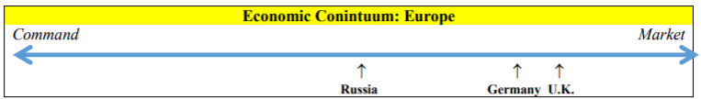

The economy of the United Kingdom may be described as mostly market-leaning. Its main economic sectors are services, manufacturing, and construction. Private and intellectual property rights are well- protected, an unemployment rates have been steadily declining. How the forthcoming Brexit will impact the U.K.’s economy remains to be seen.

Germany’s economy is slightly less market-leaning than the U.K.’s, although, in terms of GDP and per capita incomes, Germany has the stronger overall economy. The German government does regulate certain elements of state agriculture, energy, and telecommunications; the automotive and construction industries in Germany are also somewhat politically influenced, but otherwise economic decisions are left up to the German people. Germany has invested heavily in economic rescue packages for fellow Eurozone members.

The economy of Russia, on the other hand, is mostly command-leaning. Many of the market reforms Russia sought to make after the collapse of the Soviet Union have floundered in recent years. Bureaucracy is rampant in Russia, especially when it comes to starting a new business. Protection of private and intellectual property rights is weak. Russia’s extensive subsidization of the energy sector, along with its policy of import substitution, discourages foreign trade and investment. Government ownership of the vast majority of private domestic banks, shipping, and aerospace technology development have also contributed to Russia’s repressed private sector development. Furthermore, the Russian economy is dominated by the oil and natural gas industries; however, the steady drop in oil prices worldwide over the last several years has hindered Russia’s economic growth.

- Trade Benefits
Vocabulary Preview
• specialization – focusing on a narrow range of products/services that can be produced most efficiently and cost-effectively
• voluntary trade– trade in which both partners freely agree to and benefit from the exchange of goods/services

Trade between nations is only viable when it is voluntary (i.e., not coerced through military threats or economic sanctions) and mutually beneficial. When nations look for trading partners, strategic/military alliances are taken into account. Acquiring trading partners who can meet the product/service demands which one’s own country cannot meet is a far greater consideration however.

Although some nations are rich in natural resources and highly developed in terms of technologies, infrastructure, et al, it is not always in a country’s best interest financially to produce everything it is capable of. Often times nations choose to market only those products/services which they are capable of providing fastest, cheapest, and in great abundance. This phenomenon is known as economic specialization, and it is what sustains voluntary trade partnerships worldwide.

Examples of European specialization include Germany’s automotive industry, Russia’s natural gas industry, and the United Kingdom’s finance and banking industries.

- Trade Barriers

Vocabulary Preview
• boycott – refusal to purchase a good/service from a specific company or country
• embargo – a trade barrier which blocks all trade with another nation
• quota – a trade barrier which places a limit on imported goods
• sanction – the act of economically punishing another nation
• tariff – a trade barrier which places a tax on imported goods
• trade barrier – any activity which slows or outright blocks the free exchange of goods and services between nations

Voluntary trade between nations may be inhibited by trade barriers. Such barriers exist to protect domestic markets from foreign competition; others are intended to block the importation of dangerous products. Trade barriers may also be employed to sanction an enemy nation.

There are three major barriers to trade which students should be aware of in the context of Europe:

- Tariffs place a tax on imported good. This is done to artificially inflate the price of a cheaper foreign product so as to make the price of domestic products more competitive.

- Quotas place a limit on imported goods. This is done so that cheaper imports do not flood domestic markets and put domestic producers out of business.

- Embargoes block all trade with another nation. An embargo may be employed for safety reasons, but is more frequently used to punish rogue states (e.g., sanctions imposed by numerous E.U. member nations against arms sales to or energy exports from Syria.)

o A boycott of a specific product or of a specific country’s or company’s product(s) may be exercised by citizens within a country even when there is no official embargo in place at the national level.

- Currency Exchange

Vocabulary Preview

• currency – a nation’s money
• currency exchange – converting one nation’s money into an equivalent value/quantity of another’s
• euro – common currency of most European Union member states; those E.U. nations currently using the euro are referred to collectively as the Eurozone
• exchange rate – the approximate value of one nation’s currency in terms of another’s

In order for countries in Europe to trade, a system of currency exchange must exist. This is due to the fact that there are some two dozen unique currencies in use in Europe today. Case in point, nineteen of the European Union’s twenty-eight member nations use the euro for monetary exchange; the other nine are currently using their own national currencies until they meet the E.U.’s financial criteria. (E.g., Hungary uses the forint. Poland uses the zloty. Sweden uses the krona.)11 This is to say nothing of the continent’s twenty-eight non-E.U. members, such as Switzerland (Swiss franc), Norway (krone), Russia (ruble), and Ukraine (hryvnia.) Without a method to convert monetary values between disparate currencies, international trade would be impossible.

Exchange rates are used to determine how much one nation’s currency is worth in terms of another’s. (e.g., 1.00 U.S. dollar ≈ 0.96 Euros)
- European Union

Vocabulary Preview

• European Union – economic and political union of 28 European nations
• Maastricht Treaty – legal document which created the European Union
• Treaty of Lisbon – legal document which amended and consolidated the Maastricht Treaty and the Treaty of Rome, and which forms the basis of the current constitution of the European Union

The political and economic partnership which has evolved into the modern European Union can be traced back to the early years of the Cold War. Beginning in1950, a movement to consolidate coal and steel mining/refining in Europe emerged. The idea behind such a measure was twofold: first, it would help revitalize the economies of Western and Central Europe in the wake of two devastating World Wars; second, it would serve as a means by which to keep an eye on Germany and Italy and preclude another major continental war. By 1958, a distinct and interconnected economic community had emerged among Belgium, Italy, France, Luxembourg, the Netherlands, and West Germany. This economic union would, in 1992 under the Maastricht Treaty, evolve into the European Union.

The European Union today is composed of twenty-eight member states:

• Austria • Belgium • Bulgaria • Croatia • Republic of Cyprus • Czech Republic • Denmark • Estonia • Finland • France • Germany • Greece • Hungary • Ireland • Italy • Latvia • Lithuania • Luxembourg • Malta • Netherlands • Poland • Portugal • Romania • Slovakia • Slovenia • Spain • Sweden • United Kingdom

Although the U.K. intends to separate from the E.U., there are several other European nations hoping to soon join. These countries include: Albania, Macedonia, Montenegro, and Turkey.

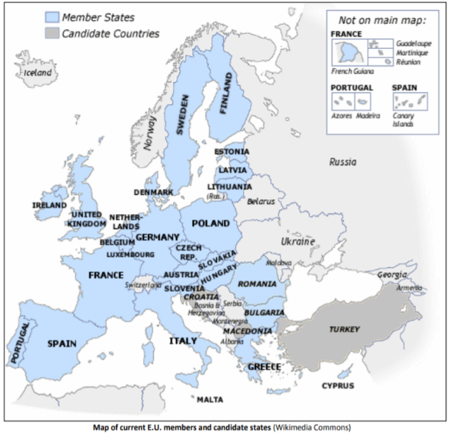
The European Union exists to promote security and economic cooperation across the continent. Conceptually, the guiding premise of the E.U. is that countries who are economically interdependent are less likely to wage war. This economic interdependence has been nurtured by abolishing border controls between member nations in order to promote the free movement of labor, through the adoption of a common currency – the euro – to facilitate intracontinental trade, and by eliminating import/export tariffs among E.U. members.

The E.U. also models and promotes transparent, democratic practices via the European Council, which serves as its general assembly. The promotion of human rights is also a major feature of the E.U. as evidenced by the Charter of Fundamental Rights of the European Union12, which became legally binding on all members states, both present and future, under the 2007 Treaty of Lisbon.

- Literacy Rates & Standard of Living

Vocabulary Preview

• Balkans – the countries of Europe’s southeastern Balkan peninsula, including Croatia, Bosnia and Herzegovina, Slovenia, Serbia, Montenegro, Kosovo, Macedonia, Romania, Bulgaria, Albania, and Greece
• literate – able to read and write in one’s native language
• literacy rate – the percent of a nation’s population over the age of 15 who are able to read and write
• standard of living – the level of wealth and material comfort available to a people

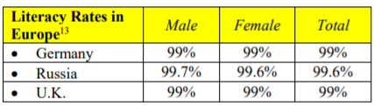
In order for a region to sustain high-quality, well-paying, in-demand jobs, its labor force must be literate. The literacy rates across Europe vary tremendously. Eastern Europe has some of the highest literacy rates, with some of the continent’s lowest being in Southern and Southeastern Europe, particularly in the Balkans.

Low literacy rates typically correlate to lower standards of living; however, high literacy rates do not always translate to higher standards of living in Europe. The United Kingdom, Germany, and Russia all have literacy rates in the 99th percentile; however, in the case of Russia, which has one of the highest literacy rates in the world, more than 13% of Russians live at or below the poverty line.

- Human Capital & Gross Domestic Product (GDP)

Vocabulary Preview

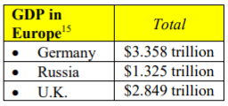
• human capital – the knowledge, skills, and relative health of a nation’s labor force

The economic strength of a nation is determined by measuring its gross domestic product, or GDP. GDP is the estimated total value of the all the final goods and services produced in a nation in a year’s time. In other words, GDP represents what a nation is worth.

Nations who wish to compete economically must maintain a competitive GDP relative to other nations’ in their region and among their trading partners. One way to ensure a healthy and growing GDP is to invest in human capital, which is to say the relative health, education, and training of a nation’s labor force. Unhealthy, poorly educated, and/or untrained workers cannot be expected to support a strong national economy, let alone obtain high-quality, well-paying, in demand jobs. Thus a nation’s GDP directly correlates to its level of human capital investment.
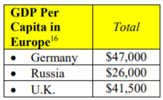
Countries who do invest in human capital tend to see a rise in GDP per capita incomes. GDP per capita measures the average annual income of citizens in a given nation. (This measure can be misleading, however, when one factors in the gap separating the impoverished, middle class, and wealthy. Such is the case in Russia where the number of millionaires per capita in Moscow skews the nation’s overall per capita measure.)

Europe has some of the highest human capital investment according to a World Economic Forum report. Of the 130 nations analyzed for 2016, Germany ranked 11th, the U.K. ranked 19th, and Russia ranked 28th.

- Capital Goods & Gross Domestic Product (GDP)

Vocabulary Preview

• capital goods – the factories, machinery, technology, etc. that are necessary to sustain a service or industry

Another factor which can greatly impact a nation’s GDP is its level of investment in capital goods (also called physical capital.) Capital goods are the factories, machinery, technology, etc. that are necessary to sustain a service or industry. Older, less efficient factories, antiquated machinery, and obsolete or out of date technology slow production and hamper the growth of national GDP. Germany has invested heavily in capital goods, particularly as relates to its automotive industry. Russia’s capital goods investment is toward oil and natural gas exploration and refinement. The United Kingdom, meanwhile, has invested in upgrading and expanding its telecommunications in support of multiple economic sectors.
- Role of Natural Resources

Vocabulary Preview

• natural resource – a material on or in the earth that has economic value

A third factor which can affect a nation’s GDP is the prevalence, diversity, and management of natural resources. In the United Kingdom, there is an abundance of rich farmland. Large forested areas support a booming lumber industry in Germany. Russia, meanwhile, has numerous rivers which it is able to dam to produce hydroelectric power. All three nations have deposits of coal, petroleum, iron ore, and natural gas.

- Role of Entrepreneurship

Vocabulary Preview

• entrepreneur – those who risk their own money and resources to create a new business or service
• private sector – the part of the economy owned and operated by private citizens
• profit – as a verb, to gain financially; as a noun, the economic gains of a business
• public sector – the part of the economy owned and operated by the national government

In any given country, public sector (i.e., government-owned) industries will maintain a nation’s GDP, but they will not typically grow it. It is in the private sector (i.e., businesses owned and operated by private citizens) that the most GDP growth occurs. A solid investment in human capital will foster the entrepreneurship necessary to generate private sector growth.

Entrepreneurs are private citizens who invest their own capital resources toward the creation of a new business or industry, frequently at some financial risk. Those whose business ideas succeed will profit; those whose do not will fail. This is the very essence of the free market / capitalist system.
Unit 3 Vocabulary - Government
• autocratic – a government where political authority rests with a single leader
• bicameral – having a legislature divided into an upper and a lower house
• chancellor – title given to the head of government in Germany
• democratic – a government where political authority rests with a nation’s citizens
• political party – an organization which represents a specific political agenda and socioeconomic positions within a given nation
• president – title often given to the head of government (and state) in a presidential democracy
• prime minister – title often given to the head of government in a parliamentary democracy
•parliament – common name given to the legislature in a parliamentary democracy
Unit 4 Vocabulary - Economics
• bartering – a system of exchange whereby one good/service is given in return for another; bartering does not require monetary exchange
• command economy – an economic model wherein government planners make all business and financial decisions
• economic system – an economic model used by governments to determine what should be produced/provided in terms of goods and services, how, and for whom
• entrepreneurship – the capacity of private citizens to create new businesses independent of government direction or intervention
• free enterprise – the creation, maintenance, and expansion of businesses outside the control or influence of the government.
• market (or capitalist) economy – an economic model which the laws of supply and demand (not government oversight) determine what is produced/consumed and at what cost
• production quota – the required amount of a specific good that must be produced in a given timeframe
• subsistence – producing only what is necessary for personal use/survival
• traditional economy – an economic model governed by custom, habit, and history
• wage – term for one’s financial earnings
• economic continuum – a 0-100 scale which ranks world economies from most command-leaning (0) to most market-leaning (100)
• mixed economy – term used to describe the market/command blending of all modern world economies
• specialization – focusing on a narrow range of products/services that can be produced most efficiently and cost-effectively
• voluntary trade– trade in which both partners freely agree to and benefit from the exchange of goods/services
• boycott – refusal to purchase a good/service from a specific company or country
• embargo – a trade barrier which blocks all trade with another nation
• quota – a trade barrier which places a limit on imported goods
• sanction – the act of economically punishing another nation
• tariff – a trade barrier which places a tax on imported goods
• trade barrier – any activity which slows or outright blocks the free exchange of goods and services between nations
• currency – a nation’s money
• currency exchange – converting one nation’s money into an equivalent value/quantity of another’s
• euro – common currency of most European Union member states; those E.U. nations currently using the euro are referred to collectively as the Eurozone
• exchange rate – the approximate value of one nation’s currency in terms of another’s
• European Union – economic and political union of 28 European nations
• Maastricht Treaty – legal document which created the European Union
• Treaty of Lisbon – legal document which amended and consolidated the Maastricht Treaty and the Treaty of Rome, and which forms the basis of the current constitution of the European Union
• Balkans – the countries of Europe’s southeastern Balkan peninsula, including Croatia, Bosnia and Herzegovina, Slovenia, Serbia, Montenegro, Kosovo, Macedonia, Romania, Bulgaria, Albania, and Greece
• literate – able to read and write in one’s native language
• literacy rate – the percent of a nation’s population over the age of 15 who are able to read and write
• standard of living – the level of wealth and material comfort available to a people
• human capital – the knowledge, skills, and relative health of a nation’s labor force
• capital goods – the factories, machinery, technology, etc. that are necessary to sustain a service or industry
• natural resource – a material on or in the earth that has economic value
• entrepreneur – those who risk their own money and resources to create a new business or service
• private sector – the part of the economy owned and operated by private citizens
• profit – as a verb, to gain financially; as a noun, the economic gains of a business
• public sector – the part of the economy owned and operated by the national government

