Europe Political Map
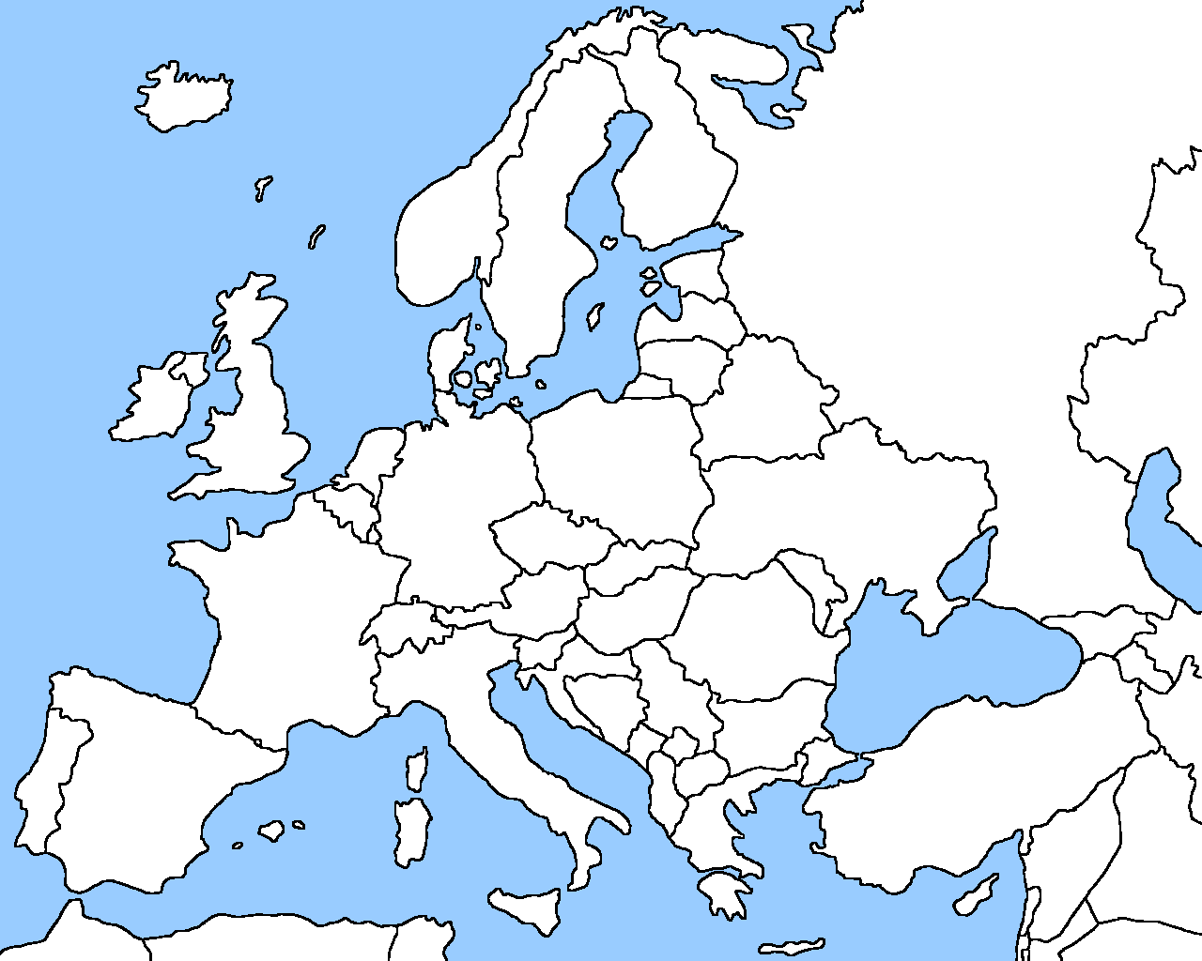
Color code and label the following countries using the maps provided. Also list the capital for each country in the map key.
Map Key  Color Country Capital  Belgium  Portugal  France  Germany  Italy  Poland  Russia  Spain  Ukraine  United Kingdom | Compass Rose

