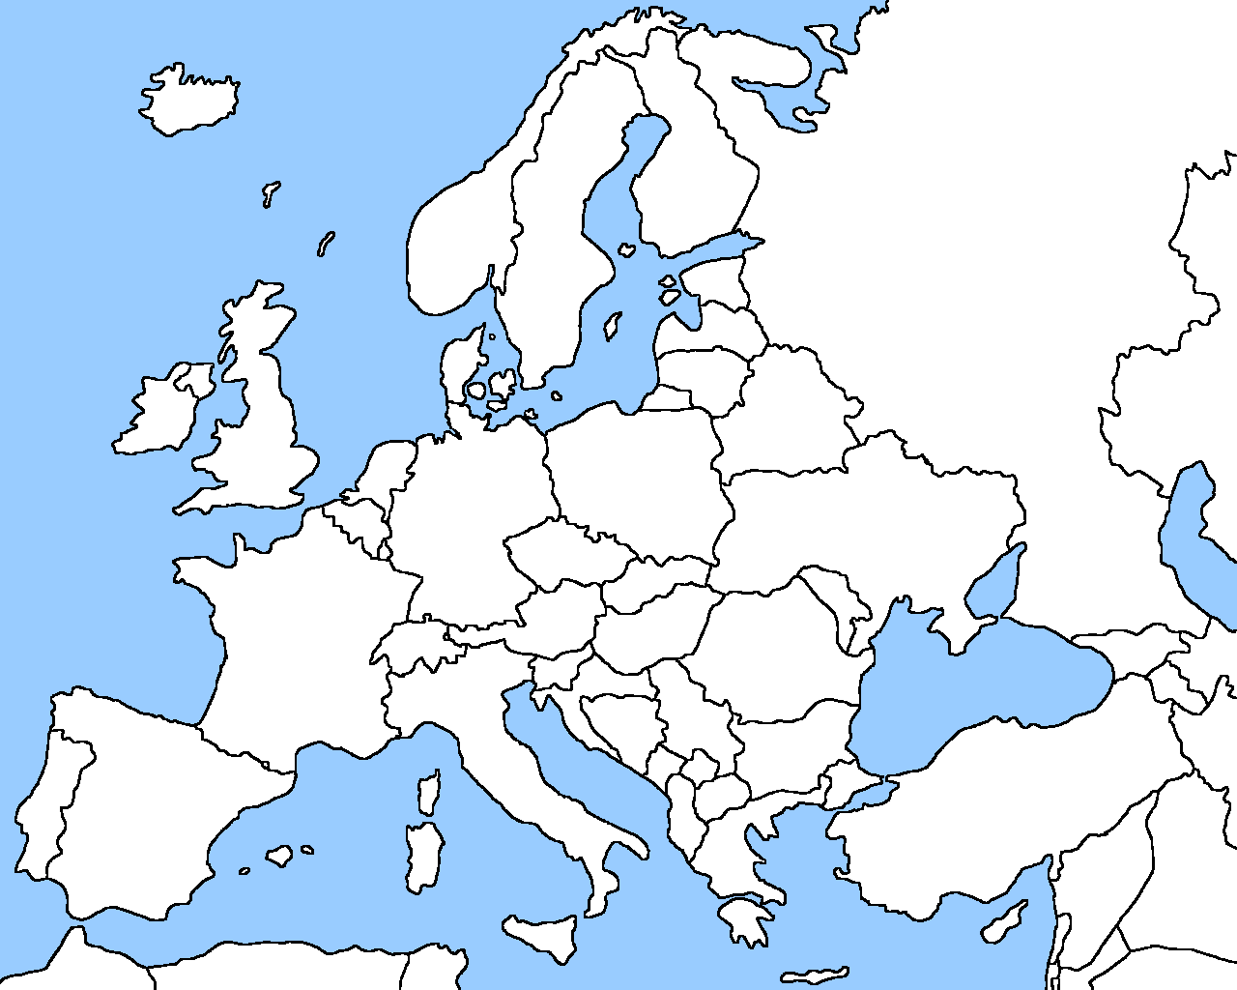
Europe Physical Map
Label the following physical features: Danube River, Rhine River, Mediterranean Sea, English Channel, European Plain, Alps Mountains, Pyrenees Mountains, Ural Mountains, Iberian Peninsula, Scandinavian Peninsula
Map Key | Compass Rose

